

Changing Lives Through learning

**Student ID 3156909**

**Student Name-Rajdeep Kaur**

**PROJECT REPORT**

# Client Details

Rajdeep is my client. He is my neighbour. He starts his new business in my area. I proposed to a new website to expand his business. The name of his Hotel is “RK HOTELS”.

|  |  |
| --- | --- |
| Company Name | RK HOTELS |
| Address | 14/18 Alicante Ave ,Manurewa, Auckland |
| Phone Number | 0220345678 |
| Email Address | [rajdeepkaursomal@gmail.com](mailto:rajdeepkaursomal@gmail.com) |
| Company Owner | Rajdeep |

# Project Scope

## Purpose

The main purpose of the website is to attract customers more and more to book the RK HOTELS. This website is very simple and attractive. People can use it easily. This website can be used with all browsers like opera browser, safari, Google chrome, internet explorer, Firefox.

## Goals

* Attracts customers

This website has many pictures of the Hotels and its packages or serviices and has a good colour schema, which can attract people more.

* Expand Booking

The reviews of the customers can increase the bookings of the Hotels.

## Features

* Online booking method

People can book room online by the adding their details on the booking page.

Awareness of the customer

This website can aware the customer by creating the profile on the website. Customers get confirmation message after adding details or new bookings by the customer.

* Information about location

People can search the nearest branches easily while your bookings of the website.

* Information about Other service

The website also Permotes the other services of the Hotel like gym, Pool, Gaming.

* Customers details

The website also gives the information to the customer like their phone number, Address, e-mail id.

## Target audience

* Men age group 18-40
* Women age group 18-40
* Children age group 8-16

# Visual Planning

1. Home page

This given website rkhotels.co.nz is the website of “RK HOTELS”. This website has no negative space.it also gives the information of the hotel like location or branch, room type, customer details, services and more . The colour schema of this website, is enhancing the beauty of the website.

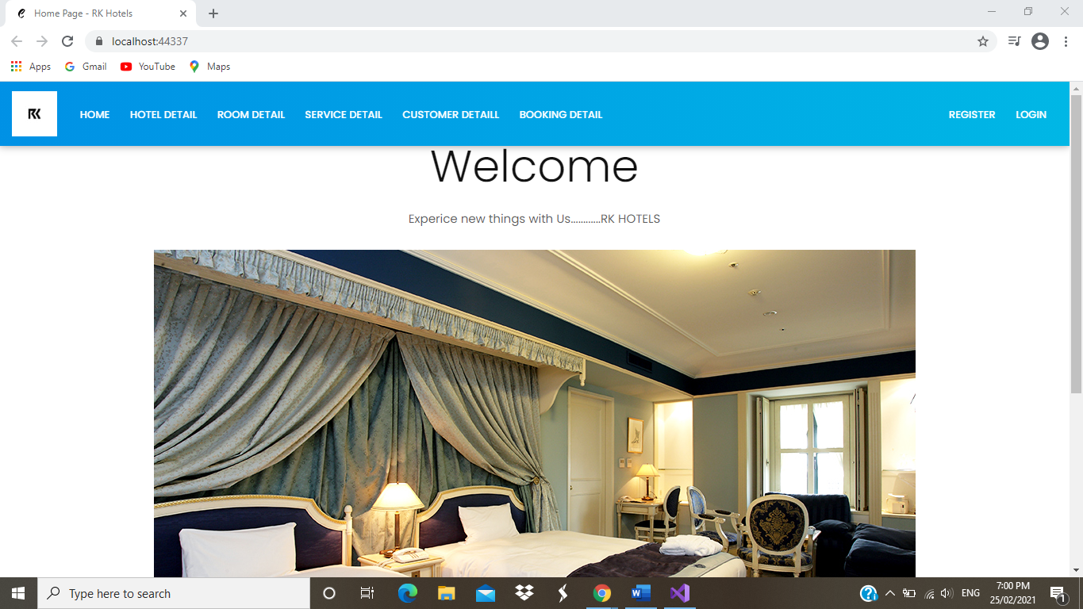

1. Hotel page

To exemplify second page of the website. This is the website Hotel page. This website provides the information about details of hotel page as well as the delete, detail, edit and create button. This website is cover some design principles also like unity, the font used in the website is increases the attraction of the customers as emphasis view point.

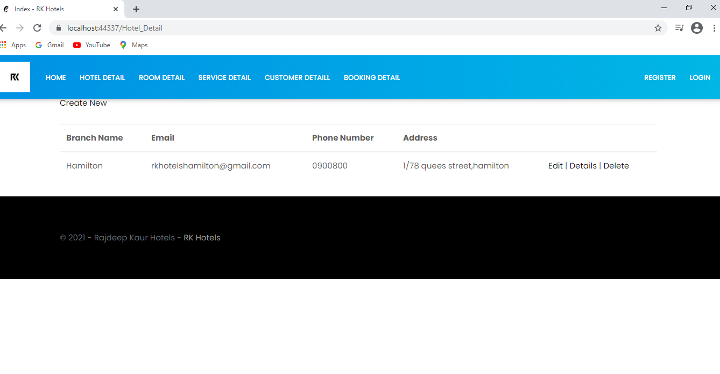

1. Room page

The third page is Room page. This page includes the information of the business details and room details. The website describes balance as well as alignment.

(Balance Symmetrical designs are always pleasing, if not occasionally boring. Asymmetrical designs are bolder and can bring real visual interest and movement (more on that later!) to your composition)

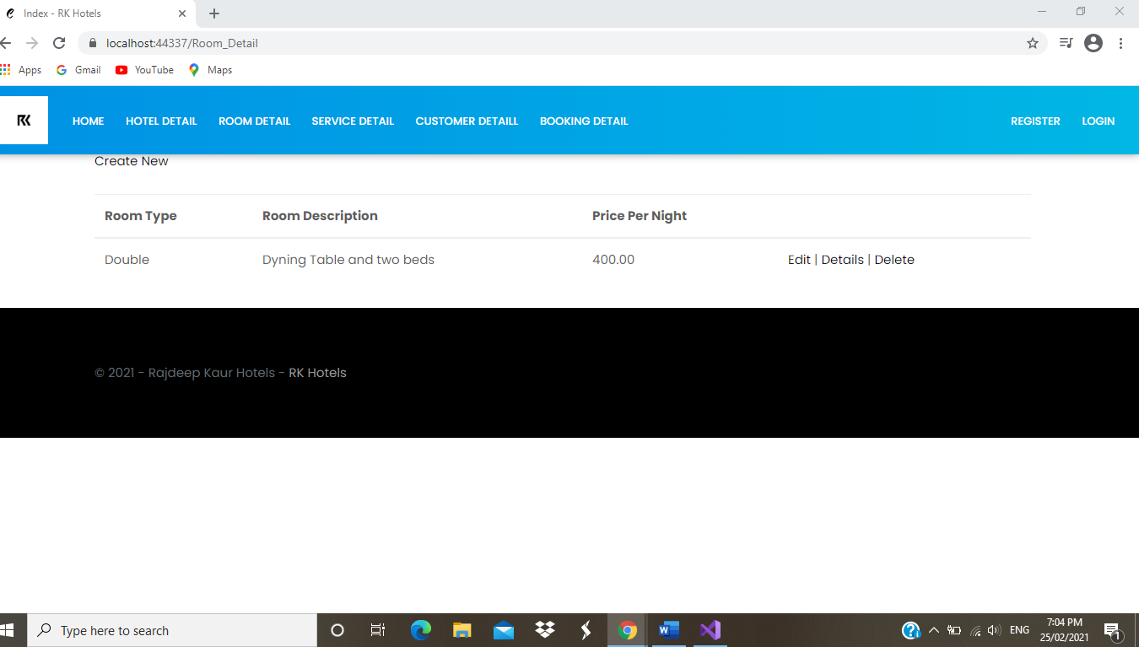

1. Customer page

The third page is Customers page. This page includes the information of the customers details. The website describes contrast from the design principals by its simple design.

(Contrast meaning is what people mean when they say a design “pops.” It comes away from the page and sticks in your memory. Contrast creates space and difference between elements in your design. Your background needs to be significantly different from the colour of your elements so they work harmoniously together and are readable)

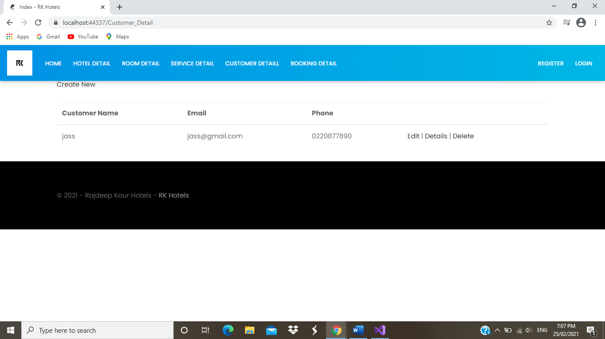

1. Services page

The third page is Services page. This page includes the information of the service details which shows the available services in the hotel. The website describes contrast from the design principals by its simple design.

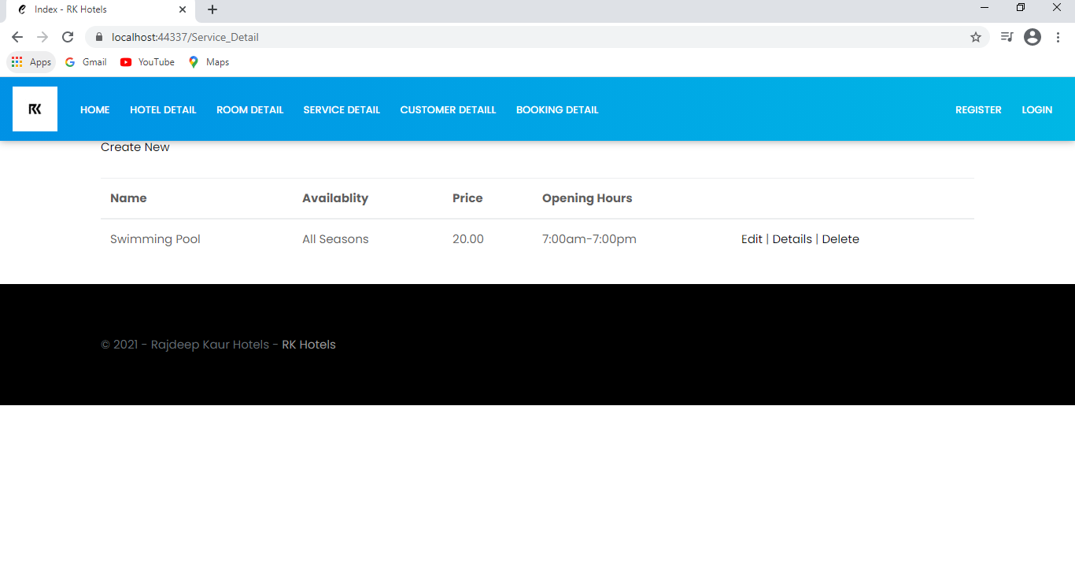

1. Bookings page

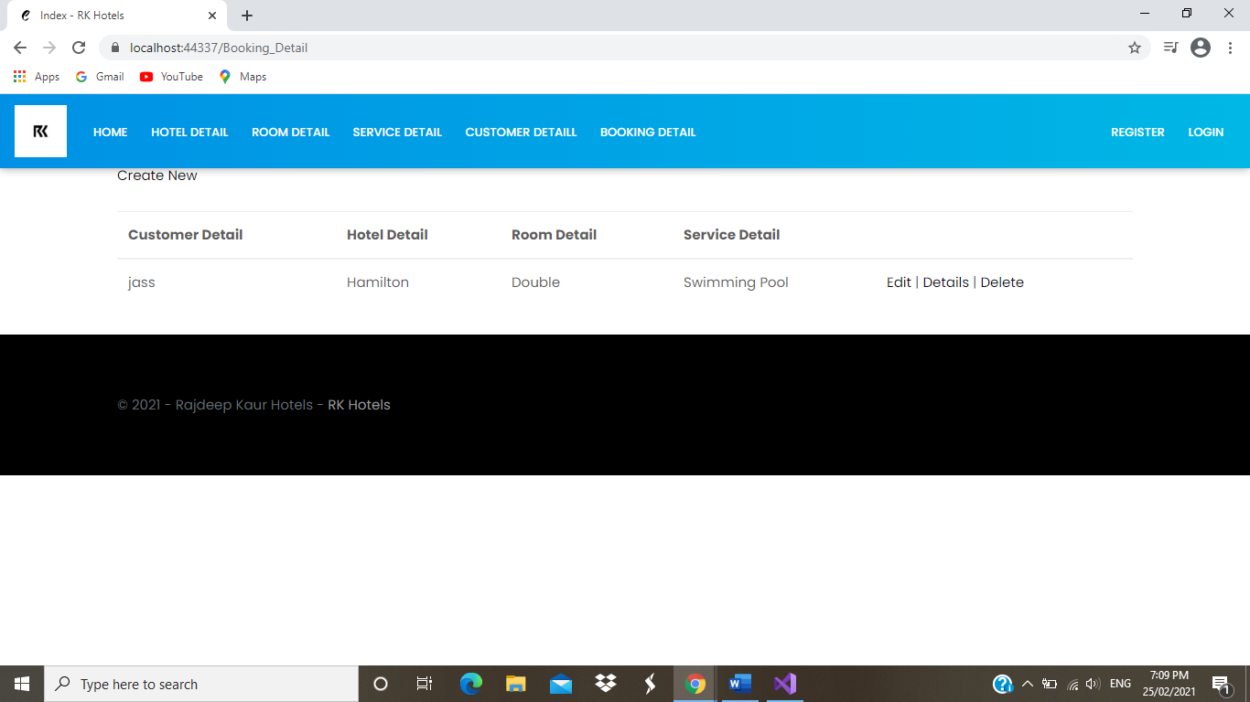

1. Footer area

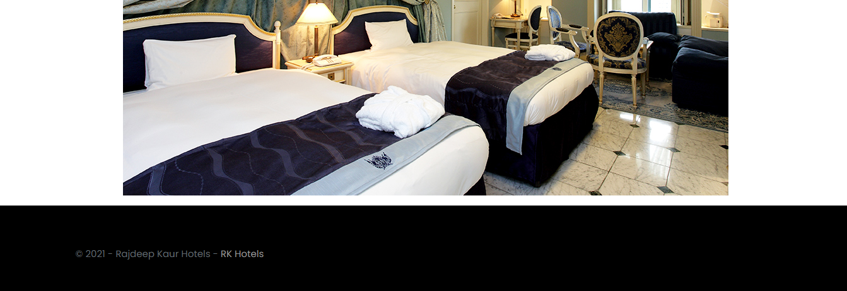

## Appearance / Style

### Colour schema

|  |  |  |  |
| --- | --- | --- | --- |
| Colour | Colour name | Colour code |  |
|  | Sky blue | **#2980B9** |  |
|  |  |  |  |
|  | white | **#FFFFFF** |  |

### Fonts

|  |  |  |
| --- | --- | --- |
| Font style | Font family | Used for |
| Calibri light (Headings) | Sans serif | Headings |
| Calibri (Body) | Sans serif | Information |
|  |  |  |

### Logo or Brand Name



Based on the name of the hotel and owner.

# Tasks Detail

Here you need to provide the Gantt chart with all tasks, estimate time for each task and total time estimation.

|  |  |  |
| --- | --- | --- |
| Weeks | Tasks | Time |
| 1 | Client details  Purpose  Goals  Features  Target audience | 60 minutes  20 minutes  20 minutes  20 minutes  20 minutes |
| 2 | Appearance and style  Page contact details  Wireframes  Sitemap  Domain names  Web hosting details | 50 minutes  140 minutes  60 minutes  20 minutes  40 minutes  20 minutes |
| 3 | Testing  Grammar, spellings ,links | 150 minutes |
|  | Total timing | 12 hr |

# Wireframes

## Page 1 wireframe

**HOME PAGE**

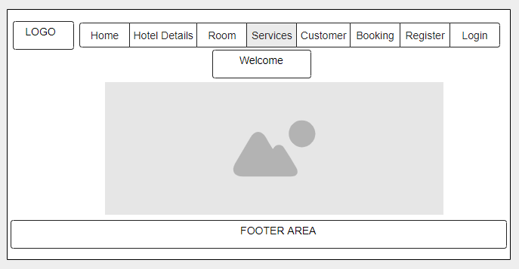

## Page 2 wireframe

**Hotel details**

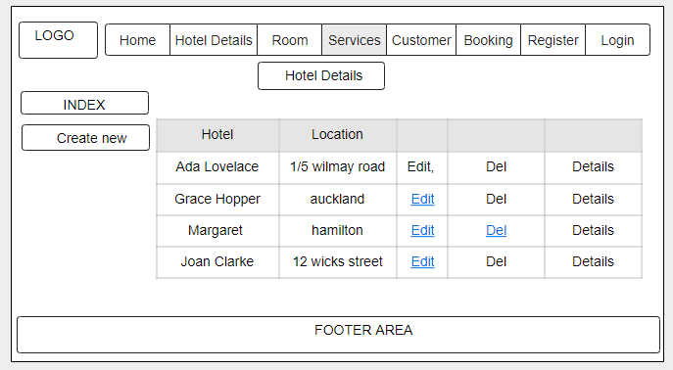

## Page 3 wireframe

**Room details PAGE**

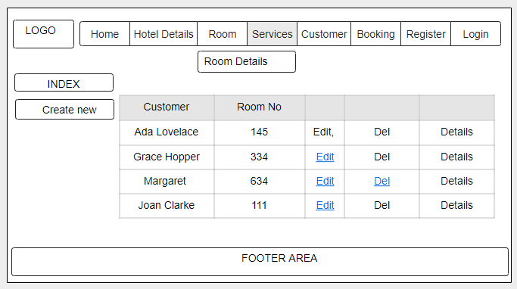

## Page 4 wireframe

**Service PAGE**

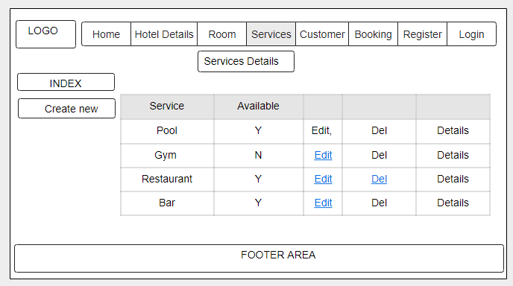

## Page 5 wireframe

**Booking PAGE**

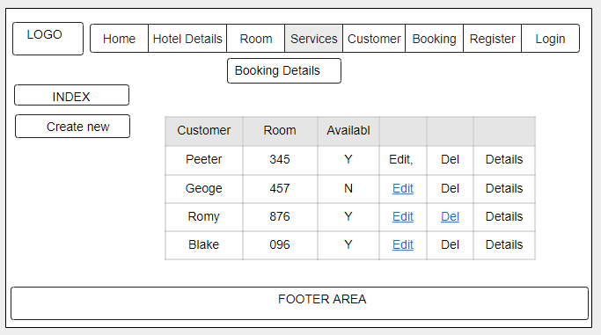

## Page 5 wireframe

**customers PAGE**

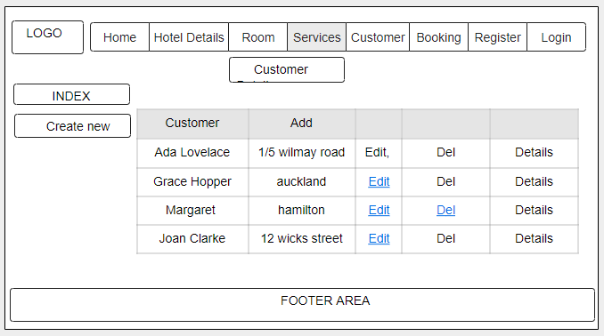

Sitemap

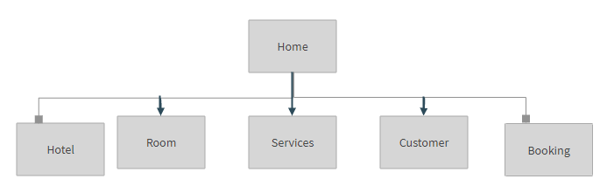

# Browser Support

The website used for RK HOTELS is a user friendly website which can be search on any browser like safari, Opera, Google chrome, Firefox, internet explorer and so on.

|  |  |  |
| --- | --- | --- |
| Number | Browser Name | Brower Version that support website |
| 1 | Safari | 5.1.7[11] (may9,2012) |
| 2 | Opera | 64 (2019) |
| 3 | Google chrome | 77.03865.120 |
| 4 | Firefox | 68.0.1 |
| 5 | Internet explorer | 11.0.155(8oct2019,6 days ago)[23] |

# Domain Names

The website used for RK HOTELS has some domain names which customer can use to open the website.

|  |  |
| --- | --- |
| No. | Domain names |
| 1 | [www.rkhotels.co.nz](http://www.rkhotels.co.nz) |
| 2 | [www.Rkgroup.co.nz](http://www.Rkgroup.co.nz) |
| 3 | <https://rkhtls.co.nz> |

# Web Hosting Companies Detail

The website used for the RK HOTELS has different hosting web companies like Host Papa, Blue host, register.com.

|  |  |  |
| --- | --- | --- |
| Number | Web Hosting Company Name | Price |
| 1 | Host Papa | Starting at $ 3.95 per month |
| 2 | Blue host | Starting at $ 4.18 per month |
| 3 | Register.com | Starting at $ 5.95 per month |

**REPORT ENDS!**